**Memorandum**

**To: Prof. Matthew Higgins and Deborah Sills, Ph.D.**

**From: Haley Kameros**

**Date: September 24, 2013**

**Class: CENG 340 Environmental Engineering Lab 3**

**OBJECTIVE**

**Influent water to a drinking water plant in Iowa is contaminated with insecticide chlordane. Chlordane is a highly toxic chemical that was commonly used as an insecticide until it was banned 25 years ago. Despite this restriction, chlordane is still detected in ground water in rural parts of America. The purpose of this lab was to assess whether treating the water with granulated activated carbon (GAC), which sorbs chlordane, will reduce chlordane concentrations to below its maximum containment level of 2 ppb.**

**METHOD**

**A set of experiments were conducted to determine the parameters for the sorption isotherm of chlordane on GAC. The resulting parameters were used to create a bench-scale treatment unit for further testing. The parameters that were measured and used were the solid mass of concentration of adsorbate (q, measured in mg/g), aqueous concentration of adsorbate (C, measured in mg/L), Freundlich isotherm soil-water partition coefficient (K, measured in (mg/g)(L/mg)), and the Freundlich isotherm intensity parameter (n, unitless). After the laboratory study was completed, data was collected in order to determine the appropriate sorption isotherm model. There were two options for the appropriate model for the data; either Linear ($q=KC$) or Freundlich ($q=KC^{1/n})$. The results were plotted and the best-fit model was determined.**

**RESULTS AND DISCUSSION**

**After plotting and fitting the solid concentration of adsorbate versus the aqueous concentration of adsorbate, the most appropriate and best-fit model was determined to be the Freundlich. This conclusion is illustrated below in Figure 1.**

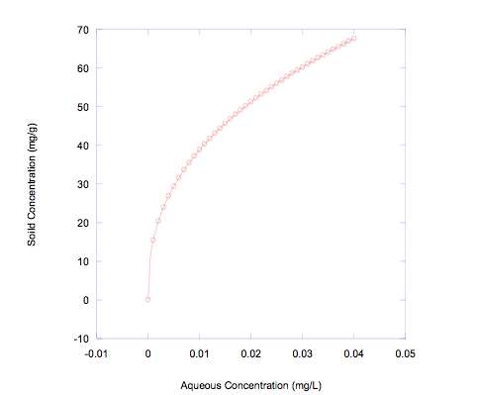

**Figure 1.** The solid concentration of adsorbate versus the aqueous concentration of adsorbate. The circles represent the collected data points and the line represents the fitted model by the Freundlich equation, $q=KC^{1/n}$.

Thus, the Freundlich equation is the best model to determine whether treating the water contaminated with insecticide chlordane with GAC will reduce the chlordane concentrations to below its maximum contaminant level of 2 ppb.